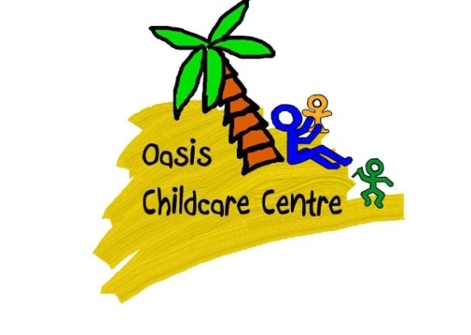
Oasis Home Learning Challenges, Summer Term 2021: Pre-School

Personal, Social and Emotional Development | Physical Development | Communication and Language | Literacy | Mathematics | Understanding the World | Expressive Arts and Design
Create a photo book of family members, friends, family holidays or trips, happy memories etc. Look at the pictures and talk about them with your child. | Practice using scissors correctly and safely – cut strips of paper, grass, leaves, foliage, etc. Create a picture using the different pieces you cut out. | Explore rhyming words though nursery rhymes and jingles – talk about which words rhyme/sound the same. Can your child think of another word that rhymes? | Bedtime story - Read your favourite story and talk about the different characters. | Go for a walk look for different numbers in the environment, such as road signs, number plates, house numbers, shop names etc. | Make a weather chart at home – check the weather each day (look out of your window or go for a walk) and change it on the chart. | Create an imaginary train/bus/car using cushions or chairs. Encourage your child to pretend to go on a journey – what will they see on the way, what do they need to take, etc.
Make an ‘Achievement Chart’ to celebrate things your child learns achieves throughout the day, such as something new your child has learnt, something new they have tried or if they have been kind or helpful. | Play action games with your family, such as:  - What’s the time Mr Wolf?  - Running races  - Egg and spoon race  - Moving like different animals  - Follow the leader. | Play Simon Says – your child will need to listen to the instructions and copy the actions. Encourage your child to also have a turn at being Simon and giving you an instruction to follow. | Make up a story with your child using their favourite toys or teddies. Encourage your child to share their own ideas about what could happen in the story. | Measure different objects you find in the house. Talk about which ones are the biggest, smallest, longest, shortest, thickest, etc. | Visit the beach or woods and go on a nature walk. Collect different treasures along the way, such as pebbles, sticks, leaves etc. Explore your natural treasures and talk about your walk when you get home (what did you see, what did you hear, what did you find?). | Dance party to different music. Dance with your child and encourage them to explore different actions and ways of moving to the music.
Playdough faces – make faces onto paper plates using dough and talk about different feelings. | Help mummy or daddy to make dinner – chop up fruit/vegetables, mix ingredient, help clean surfaces and wash the dishes. Talk about safety and hygiene routines. | Sensory play to explore textures and prompt discussions with your child, such as ice cubes, gloop, shaving foam etc. | Help your child to write a letter to a friend of family member. Encourage them to share their ideas and practice forming letters. | Sorting and counting with pasta shapes – sort different pasta shapes into containers. Count how many in each group and talk about more/less/the same. | Shadow puppets - Build a snug den using blankets and/or sheets. Turn off the lights and use torches to make shadows with your hands or objects. | Junk modelling construction – use various boxes, cardboard tubes, food packaging etc from around the house to create models and structures.

